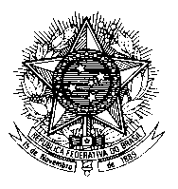

Permanent Mission of Brazil to the United Nations Office
and other International Organizations in Geneva

Human Rights Council
26th session of the UPR Working Group
Moldova

Mr. President,
Brazil welcomes the delegation of the Republic of Moldova to the UPR and thanks it for the presentation of its National Report.
Brazil recommends that Moldova:
1. Further strengthen measures aimed at combating discriminatory practices towards minorities, in particular the Roma community; and
2. Ensure that policies and services relating to mental health treatment and psychiatric institutions comply with international human rights law.

We welcome legislative reforms aimed at strengthening criminal sanctions for torture, inhuman or degrading treatment.

We note with appreciation the adoption of Law No.71, which provides for a number of initiatives focusing on the promotion of gender equality and greater participation of women in political and public life.

Nonetheless, we remain concerned about the insufficient implementation of laws aimed at the elimination of discrimination against women and the persisting high rates of domestic violence. Brazil encourages the government of Moldova to work in its new "strategy on the prevention and combating violence against women and domestic violence" with a view to further strengthening mechanisms to prevent, investigate and punish all cases of violence against women.

