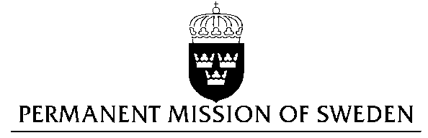
UN Human Rights Council

UPR 26th session

Statement by Sweden in the interactive dialogue on Moldova

Delivered by Dr Jannie Lilja, First Secretary
Geneva, November 4, 2016

Mr President,

Sweden wishes to welcome the delegation of Moldova.

Sweden recommends the Government of Moldova:

- To adopt the draft law on amending and completing the Criminal Code and the Code of Administrative Offences with regard to bias-motivated crimes and incidents to also include sexual orientation, gender identity and gender expression as ground for hate crimes.

- To amend Article 1 of the Law on Ensuring Equality by including criteria such as social origin, marital situation, health status, sexual orientation, gender identity, and gender expression in the main list of criteria for categories to be protected from discrimination.

- To ratify the Convention of the Council of Europe on preventing and combating violence against women and domestic violence (Istanbul Convention).

- To ensure media plurality and independence, and to take into account the opinions received from the OSCE and the Council of Europe, as well as from civil society, when adopting a new audiovisual code.

Domestic and sexual violence is still widespread in Moldova and closely linked to gender inequalities and gender stereotypes. According to a recent study with Moldovan respondents 27 percent consider that a woman should tolerate violence to preserve the family. Very few cases of abuse are reported.

I thank you Mr. President

