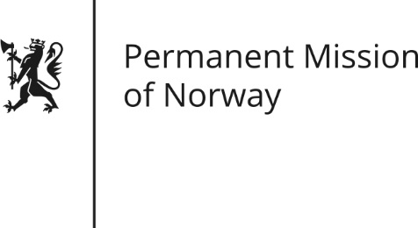

STATEMENT
Universal Periodic Review (UPR): MOLDOVA

by Human Rights Director, Lajla Brandt Jakhelln
Friday 4 November 2016

President,
Norway welcomes the delegation from Moldova, and thanks the delegation for the presentation of their national report.
Although progress has been made in many areas, challenges remain. Prison conditions are still cause for concern. Reports of mistreatment and torture by police are still relatively common. We recommend that Moldova takes further measures to improve the treatment of persons arrested, detained or imprisoned, including by strengthening the National Preventative Mechanism (NPM).
Also, while independence of the judiciary is guaranteed by the constitution, this remains a challenge in practice. In order to reduce corruption in the judiciary, increased transparency is of the essence. We recommend that Moldova takes measures to improve the procedure of appointment, transfer and promotion of judges in order to provide transparency in the judicial system and that the selection of judges is based on merit and not on the discretion of the Supreme Council of Magistracy.
While Moldovan laws also ensure press freedom and freedom of expression, reports point to issues such as the ownership structure of the media and self-censorship by journalists from fear of reprisals.
It is also crucial that the authorities and the police continue to allow the right to peaceful assembly and take a measured approach in accordance with the law and in line with international standards – which is largely the case today. Norway recommends that the Moldovan government takes concrete measures to address the issue of self-censorship among Moldovan journalists, limit media ownership concentration and ensure media pluralism.
Thank you

