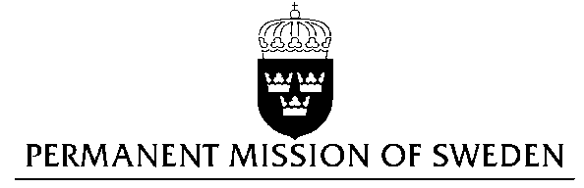
UN Human Rights Council

UPR 26th session

Statement by Sweden in the interactive dialogue on Lithuania

Delivered by Minister-Counsellor Josefin Simonsson Brodén
Geneva, November 2, 2016 (speaking time 1 min 50 sec)

Mr President,

Sweden wishes to welcome the delegation of Lithuania.

Sweden recommends the Government of Lithuania:

- To expedite the ratification of the Council of Europe Convention on Preventing and Combating Violence against Women, and Domestic Violence (the Istanbul Convention), and to harmonize its legislation in accordance with the Convention without delay.

- To prohibit all forms of violence against children in all settings, including corporal punishment, and to provide for measures to enforce its prohibition.

- To ensure that effective investigations of incitement and agitation to hatred and violence, and hate crimes on grounds of sexual orientation and/or gender identity are carried out.

We welcome that Lithuania signed the Istanbul Convention in 2013, but are concerned that the Convention has not yet been ratified.

The Law on Protection against Domestic Violence that entered into force in 2011 does not ensure protection of children against all forms of violence, including corporal punishment. Parts of society continue to tolerate physical abuse as a means of "disciplining" children.

Therefore we look forward to the prohibition against corporal punishment in all settings being approved, as proposed in the 2014 draft Law on the Fundamentals of Child Rights Protection.

Lithuania remains one of the most negative societies against LGBTI persons in the EU, according to international surveys. The aggravating circumstance established under the Article 60.12.1 of the Criminal Code has never been applied in practice.

I thank you Mr. President

