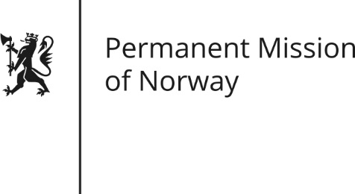

STATEMENT
Universal Periodic Review (UPR): LITHUANIA

by Minister Kjersti Sommerset, Deputy Permanent Representative

Wednesday 2 November 2016

Check against delivery
Norway thanks the Lithuanian delegation for presenting their national report.
Norway notes progress made in Lithuania regarding several important human rights issues, such as the implementation of legislation on domestic violence. Follow up is needed to secure necessary resources and capacity. We encourage awareness raising concerning domestic violence, including violence against children. Initiating the process of de-institutionalization is commendable; sufficient funding, education and political will must be in place to ensure its speedy implementation.
Norway commends significant progress in ensuring the right of assembly for LGBTI community during the Baltic Pride march in 2016. However, further effort is necessary to prevent discrimination and hate speech against the LGBTI community. Potentially homophobic legislative initiatives should be reevaluated. Norway recommends that the law on protection of minors is not applied with a view to censoring LGBTI persons related information.
Furthermore, Norway recommends discarding efforts to narrow down and legally entrench a restrictive definition of family based exclusively on heterosexual marriage that could be considered discriminatory. An inclusive concept of partnership, also for same-sex couples, would be a positive step.
Norway works closely with Lithuania in promoting a more open and inclusive society through supporting the Lithuanian non-governmental sector and cooperates with state institutions in areas such as correctional system reform. Norway commends efforts of the Lithuanian government to improving the correctional system, although significant efforts are still needed.
Norway recommends that legislative initiatives pertaining to civil society are assessed in order to make sure that they do not unjustly restrict the scope of action of non-governmental organizations. We encourage discussions with civil society in order to establish and maintan constructive partnerships in addressing human rights issues.

