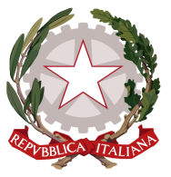
Permanent Mission of Italy to the
International Organizations in Geneva
Check against delivery
UPR – Lithuania
2 November 2016

Thank you, Mr. President.

We welcome the distinguished delegation of Lithuania and thank them for their national report and presentation.

Italy welcomes the efforts and the progress achieved by Lithuania since its first cycle of the UPR.

Italy particularly commends the adoption of the fourth National Plan on Equal Opportunities for Women and Men and its awareness campaigns that allowed to enhance gender equality.

When it comes to fighting violence against women and domestic violence, Italy welcomes the adoption of the National Programme for the Prevention of Domestic Violence, the improvements in the legislative framework and the more efficient assistance provided to violence victims by the network of specialized assistance centers administrated by non-governmental organizations.

Italy encourages Lithuania to continue in deepening progress on fighting violence against women and domestic violence and we recommend to ratify the Council of Europe Convention on preventing and combating violence against women and domestic violence (Istanbul Convention).

We wish Lithuania a successful UPR.

I thank you.

