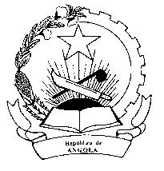
Mission Permanente
République de l'Angola
Genève

STATEMENT OF THE REPUBLIC OF ANGOLA
ON THE ADOPTION OF HAITI REPORT ON UPR SECOND CYCLE

Mr. President,

The Republic of Angola welcome the delegation of Haiti and congratulates them for the presentation of report on the second cycle of the UPR.

Angola comends Haiti for the excelente co-oporation with the human rights mecanism, on ratification of many Human rights internacional instruments and the significant progress made on the achievement of most of the Millennium Development Goals after the 2010 earthquake, unfortunazelly devastated by the recent hurricane Mathew. Angola expresses condolences to the victms.

While we welcome the launching of the Humanitarian Response Plan in 2016, Haiti still facing many barriers on food nutrition, access to education, improvement of prisons facilities, prison overcrowding, gender equality, high displacement of people, agraveted by the negative impact of the 2010 earthquake and the hurricane Mathew.

We appeal the international Community to double efforts in assisting Haiti, to overcome the challenges they faced with the aim to bring stability for the enjoyment of political, economic, social and cultural rights of their people.

Angola would like to recommend Haiti :
- To implement measures to combate prison overcrowding;

- To continue to implement measures to reduce the high rate of diplaced people ;

- To promote a disaster risk awareness campaign throughout the country;

Thank you very much

