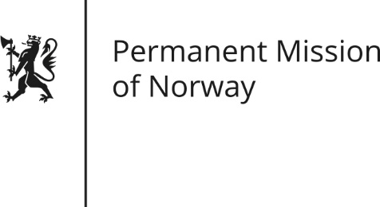

STATEMENT
Universal Periodic Review (UPR): HAITI
by Minister-Counsellor, Herborg Fiskaa Alvsåker

Norway welcomes the delegation of Haiti and would like to express our deepest condolences after the passage of Hurricane Matthew in Haiti in October.
We recognize the challenges of widespread poverty in Haiti, as well as the challenges the country is facing due to frequent natural disasters, but we still strongly underline the importance of increased efforts to protect human rights.
We acknowledge Haiti’s efforts to ratify UN human rights conventions. Yet we encourage Haiti to make intensified efforts towards implementation and recommend that the Government takes steps to ratify the Convention against Torture and other Cruel, Inhuman or Degrading Treatment or Punishment.
We further recommend that the Government strengthen its work to promote a human rights culture throughout the country and to ensure rule of law and equal treatment before the law.
Norway observes that there are challenges relating to gender equality and women’s rights in Haiti. We recommend that Haiti continue its efforts to promote gender equality, including by taking concrete measures to combat the high level of violence against women.
Finally we wish to raise the issue of the rights of the child, in particular the lack of access to education. More specifically, we recommend Haiti to take strong measures to prevent child labour and make sure that children who are employed as domestic help, the so-called “restaveks”, can go to school.

