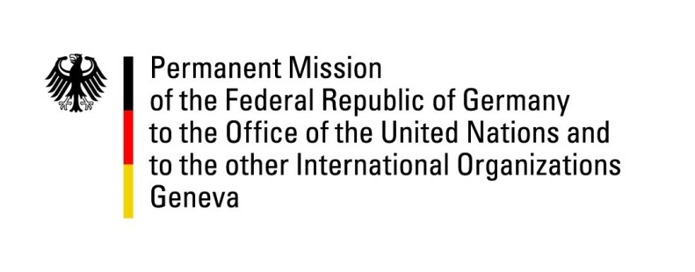

United Nations Human Rights Council
26th Session of the UPR Working Group

Geneva, 7 November 2016
---
German recommendations
to
Haiti

Mr. President,
Germany would like to thank the delegation of Haiti for the report presented today. We express our deepest sympathies for the people and the Government of Haiti and recognize the good cooperation between the Government of Haiti and the international community while facing the current humanitarian crisis.
Germany is concerned about ongoing mass evictions, including those from displacement camps. With respect to the implementation of the National Policy on Housing and Habitat, we identify the need to ensure access to adequate housing on the basis of non-discrimination.
Moreover, Germany is concerned about alleged domestic mistrust against the justice system in Haiti and its employees due to the high rate of corruption.
Therefore, we would like to offer the following recommendations to the Government of Haiti:
- End all enforced evictions from displacement camps and establish an official moratorium on mass eviction until all legal and procedural safeguards compliant with international human rights standards are in place.
- Ensure sufficient human resources in the justice system, including the Supreme Court of the Judiciary, to enable its independent operation, to decrease the number of persons in preventive custody and to guarantee the right to a fair trial.
- Ratify the Rome Statute of the International Criminal Court which was already signed in 1999 and guarantee its full implementation into national law.
Thank you Mr. President.

