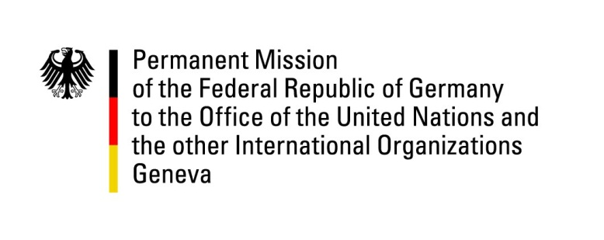

United Nations Human Rights Council
25th Session of the UPR Working Group
Geneva, 11 May 2016

---
German recommendations to Thailand

German National Statement

Mr. President,
The German delegation welcomes the delegation of Thailand to the UPR.
While appreciating Thailand’s advances in some areas of Economic Rights and Gender Equality, Germany is deeply concerned about human rights violations, in particular restrictions of the rights to freedom of expression, association and assembly, and measures facilitating impunity for the perpetrators of human rights violations.
We look forward to the dialogue and offer the following recommendations:
- End the trial of civilians in military courts and ensure that all civilians are tried before civilian courts and are granted the right to fair trial and to bail, in line with Thailand’s obligations as a State party to the ICCPR.

- Ensure that the right of freedom of opinion and expression is respected, including by reviewing Art 112 of the penal code. Ensure a safe environment that allows and promotes the rights of all people to freely associate and assemble without hindrances.

- Ratify the 1951 Convention Relating to the Status of Refugees and implement legislation establishing asylum procedures and providing asylum seekers and refugees with legal status in line with international standards, especially abiding the principle of non-refoulement.

- Establish an official moratorium on executions. Sign and ratify the Second Optional Protocol to the ICCPR and aim to abolish the death penalty before the next UPR cycle.

Thank you, Mr President.

Questions submitted in advance

- Germany shares concerns that the continued enforcement of Thailand’s lèse-majesté legislation limits the rights to freedom of opinion and expression. How has Thailand implemented the recommendations regarding freedom of expression and public and transparent proceedings as accepted during the first cycle in 2011?

- Germany welcomes Thailand giving shelter to refugees but deems it necessary to offer them legal status. Thus, we would like to ask whether Thailand intends to sign and ratify the 1951 Geneva Convention of Refugees and create national legislation granting adequate legal protection to refugees?

