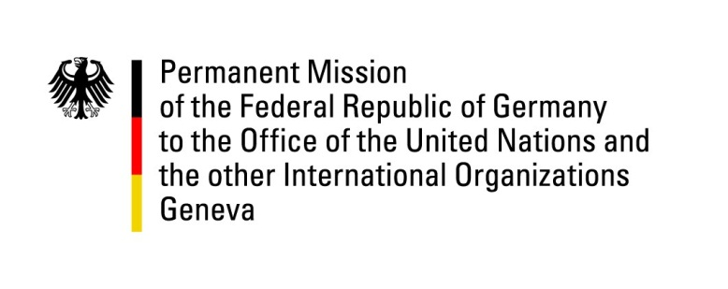

United Nations Human Rights Council
25th Session of the UPR Working Group
Geneva, 6 May 2016

---
German recommendations to Tajikistan

German National Statement

Mr. President,
Germany welcomes the delegation of Tajikistan to the UPR.
Despite some encouraging signs concerning torture – in particular a project for legislation out-ruling the use of evidence gathered through forced confessions – the country has not fully implemented the Convention Against Torture, and there continue to be credible reports of torture, mostly in pre-trial detention, but also in prisons and other detention facilities, and in the military.

Tajikistan has accepted to ratify the Second Optional Protocol to the ICCPR and called for a working group for the suspension of the death penalty. This has not been implemented.

Germany remains concerned about widespread reports of human rights violations in the country, and wishes to make the following recommendations:
- Systematically implement the Convention Against Torture, ratify the Second Optional Protocol to the Convention Against Torture, and set up an effective National Preventive Mechanism as soon as possible, at the latest until the next UPR.
- Grant ICRC missions full access to prisons and detention centers for independent monitoring.
- Ratify the Second Optional Protocol and abolish the death penalty without delay, but until the next UPR by the latest.

Thank you, Mr. President.

Questions submitted in Advance:

- Could the Tajikistan please elaborate on when it plans to ratify the Optional Protocol to the Convention against Torture and Other Cruel, Inhuman or Degrading Treatment or Punishment, and the Second Optional Protocol to the International Covenant on Civil and Political Rights (ICCPR)?
- Although there has been some progress regarding the access of observers to prisons and detention facilities, in view of ongoing reports of ill-treatment of detainees, Germany would like to ask if Tajikistan has any further plans regarding the access to prisons and detainment facilities by national and international observers, especially the ICRC?

