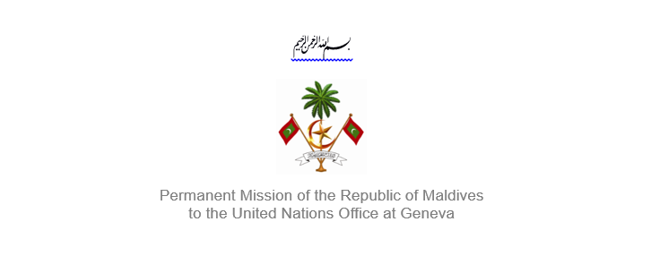25th Session of the Working Group of the Universal Periodic Review
2 – 13 May 2016, Geneva

Review of Tajikistan
6 May 2016

Statement by Ms. Rishfa Rasheed, Counsellor
Permanent Mission of Maldives to the United Nations Office at Geneva

Check against delivery

Thank you, Mr. President,

The Maldives welcomes the delegation of Tajikistan to this review, led by the Honorable Minister of Justice. We appreciate the mid-term report submitted by the delegation.

The Maldives welcomes the establishment of an office on the rights of the child within the Executive Office of the President, as well as the Human Rights Education Programme 2013-2020 and the National Inclusive Education Policy for Children with Special Needs.

The Maldives makes the following recommendations:

- Ensure access to clean drinking water is provided to the whole population
- Improve the quality, availability and accessibility of primary health-care services, to reduce high rates of infant and maternal mortality
- Take definitive measures to end child marriages

We note the decrease in relative poverty and extreme poverty, and urge the Government to continue efforts to ensure an adequate standard of living, and also address the needs of the poor and marginalized in the society.

We wish the delegation of Tajikistan success during this review.

Thank you Mr. President.

