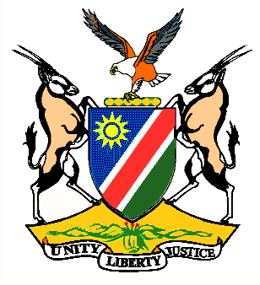

EMBASSY/PERMANENT MISSION OF THE REPUBLIC OF NAMIBIA

REPUBLIC OF NAMIBIA

Statement by H.E. Sabine Böhlke-Möller, Permanent Representative during the Interactive Dialogue on the Universal Periodic Review of Swaziland, 10 May 2016, 09h00 – 12h30

Mr. President,
Namibia welcomes the delegation of the Kingdom of Swaziland, led by…………………..to this Session of the UPR and commends them on the presentation of their national report.
Namibia commends the Kingdom of Swaziland for the provision of small financial grants to older persons and efforts to improve the lives of women with disabilities and widows, this despite the financial constraints faced by the Government.
We are pleased to take note of the adoption of the Extended National Strategic Framework on HIV/AIDS (2014-2018), which amongst others, aims at reducing new HIV infections among adults and children. We remain cognizant of the threat of this disease to the prosperity and well-being of the people of Swaziland and extend our solidarity to them in fighting this disease.
Namibia would like to recommend:
1. That the Government of Swaziland adopts the Sexual Offences and Domestic Violence Bill especially to protect women from gender-based violence.
2. That the Government of Swaziland considers ratification of the Second Optional Protocol to the ICCPR with a view to a de jure abolishing of the death penalty.
We wish Swaziland all the best during their review.
I thank you Mr. President.

