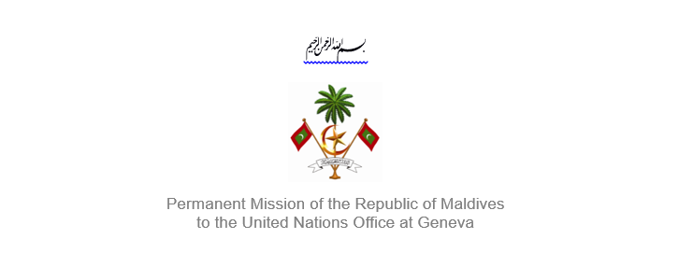25th Session of the Working Group of the Universal Periodic Review
2 – 13 May 2016, Geneva

Review of Swaziland
10 May 2016

Statement by Ms. Rishfa Rasheed, Counsellor,
Permanent Mission of Maldives to the United Nations Office at Geneva

Check against delivery

Thank you, Mr. President,

The Maldives welcomes the delegation from Swaziland to this review. The Maldives expresses its appreciation for the national report.

The Maldives welcomes Swaziland’s adoption of the Child Protection and Welfare Act 2012, which focuses on abuse prevention and primary education for all children without discrimination. Protecting and promoting the rights of children is essential to fostering the success of future generations is an important priority for the Maldives.

The Maldives would like to make the following recommendations:
- Take action to ensure the legal age of marriage of 18 years is enforced nationwide for both boys and girls
- Expedite implementation of the National Disaster Management Act

The Maldives positively recognizes Swaziland’s progress in ensuring access to safe drinking water to its people. We wish the Government success in its efforts to ensure 100% access in the near future, with the objectives of the 2030 Agenda and the Sustainable Development Goals in mind.
Finally, we wish the delegation of Swaziland success during this review.

Thank you Mr. President.

