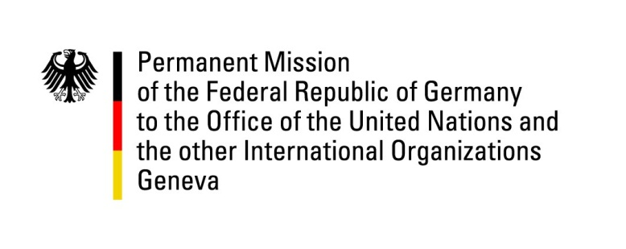

United Nations Human Rights Council
25th Session of the UPR Working Group
Geneva, 10th May 2016

---
German recommendations to Swaziland

German National Statement

Mr. Vice-President,
Germany welcomes the delegation of the Kingdom of Swaziland and thanks for its national report as well as its engagement in the UPR process.
We are concerned that the human rights situation, in particular in relation to civil and political rights, could have been improved more with more significant efforts since the last UPR in 2011. In fact, we see a negative trend in the areas of freedom of expression and press freedom and have also noted that political parties are still not able to participate in elections.
Germany recommends the following:
- Ratify the Second Optional Protocol to the International Covenant on Civil and Political Rights.
- Repeal or amend the Suppression of Terrorism Act of 2008 with a view to bringing it in line with international human rights obligations.
- Enact into law the “Sexual Offences and Domestic Violence Bill” without further delay.
We wish the Kingdom of Swaziland success in its review.
Thank you.

Written questions submitted in advance
- How will Swaziland ensure that not only individuals but also political parties will be able to participate in future elections? What legal framework will it institute to ensure this? What is the envisaged timeline to bring this about?
- What steps is Swaziland taking to align its domestic law with its obligations under the Convention on the Elimination of All Forms of Discrimination against Women?
- What is Swaziland’s assessment of its efforts to protect and promote the human rights to water and sanitation?

