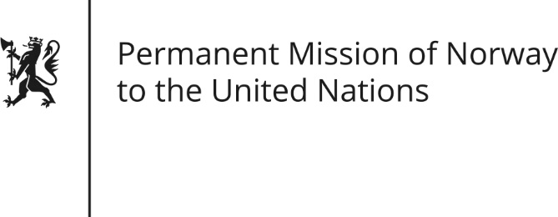

STATEMENT

Universal Periodic Review of Sudan, 4 May 2016.

Norwegian statement by Andreas Gahr Brunsvig.

Thank you,

We welcome the delegation of the Sudan.

We commend the Government of Khartoum for having established a human rights commission, for efforts to reduce child marriages and for taking steps to lift corporal punishment for so-called “indecent clothing”. The signing of the AUHIP Roadmap is also commendable. We are hopeful that this process may lead to peace and stability in the Sudan.

Protection of human rights and the expansion of democratic space is fundamental to overcome the violent internal conflicts, and essential for a genuine, comprehensive and truly inclusive dialogue for peace, democratic government and development in the Sudan.

We recommend the Sudanese authorities:
- To ensure independence and adequate financial resources for the Sudanese Human Right’s Commission.
- To revise the National Security Act of 2010 to bring it in line with international standards; in particular to end immunity provisions and to ensure that human rights violations by armed forces, police and NISS, including the Rapid Response Force are investigated and prosecuted.
- To develop a code of conduct, or similar type of document, for the respect for human rights within the armed forces and the police and provide them with training on their human rights obligations in cooperation with international partners like the OHCHR.
- To sign and ratify the African Union’s Maputo protocol on the rights of women in Africa.
- To take concrete steps to ensure freedom of expression, including for the media, and to ensure that all alleged attacks against journalists and human rights defenders are promptly and independently investigated and that perpetrators are held accountable with the view to bring such practices to an end.

Thank you.

