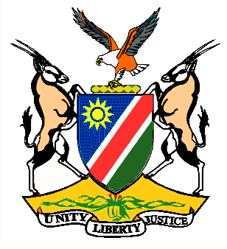

EMBASSY/PERMANENT MISSION OF THE REPUBLIC OF NAMIBIA

REPUBLIC OF NAMIBIA

Statement by H.E. Sabine Böhlke-Möller, Permanent Representative during the Interactive Dialogue on the Universal Periodic Review of Sudan, 04 May 2016, 09h00 – 12h30

Mr. President,
Namibia welcomes the delegation of Sudan to this Session of the UPR and commends them on the presentation of their national report.
Namibia is pleased to take note of the legislative developments in the Sudan during the past three years, including the adoption of the Anti-Human Trafficking Act of 2014, the Freedom of Information Act of 2015 and the Transparency, Integrity and Anti-Corruption Act of 2016.
The efforts undertaken by the Government of Sudan in protecting and promoting the social, economic rights of its people, especially the efforts relating to the right to food, housing, water and sanitation and education, is commendable. The fulfillment of these rights contributes to instilling confidence and stability amongst the population.
We encourage the Government of Sudan to remain committed and engaged on the negotiations under the auspices of high-level mechanisms of the African Union in order to resolve the issue regarding the Southern Kordofan and Blue Nile.
Namibia would like to recommend:
1. The Government of Sudan to consider ratification of the CEDAW and the Protocol to the African Charter on Human and Peoples’ Rights on the Rights of Women in Africa and to review its domestic legislation with the aim to eliminate discrimination against women.
2. The Government of Sudan to consider imposing a moratorium on the death penalty with a view to abolish it and to take measures to ensure that it is never applied to persons under the age of 18 years.
We wish Sudan all the best during their review.
I thank you Mr. President.

