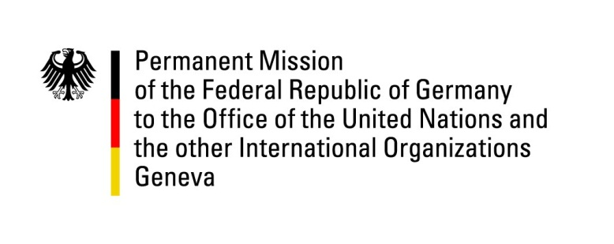

United Nations Human Rights Council
25th Session of the UPR Working Group
Geneva, 3 May 2016

---
German recommendations to Samoa

German National Statement

Mr. President,
The German delegation welcomes the delegation of Samoa to the UPR.
Germany welcomes the steps taken by Samoa to promote human rights, especially through the creation of a National Human Rights Institution. We urge Somoa to additionally consider the ratification of the main human rights conventions.
While appreciating measures taken to promote children’s rights – including legislation guaranteeing free schooling to all students attending primary and secondary education – we continue to be worried about reports of widespread violations of children’s rights.
We look forward to this dialogue with the international community and offer the following recommendations:
- Ratify the Convention against Torture and Other Cruel, Inhuman or Degrading Treatment or Punishment and its Optional Protocol and the International Covenant on Economic, Social and Cultural Rights by the third UPR review at the latest.
- Ratify the Optional Protocol to the Convention on the Rights of the Child on the Sale of Children, Child Prostitution and Child Pornography.
- Take active steps to further promote children’s rights by spreading awareness against domestic violence and child labor and emphasizing the importance of students’ school attendance.

Thank you, Mr President.

