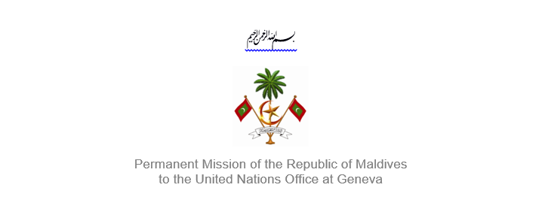
25th Session of the Working Group of the Universal Periodic Review
2 – 13 May 2016, Geneva

Review of Samoa
3 May 2016

Statement by Her Excellency Dr Hala Hameed, Ambassador /
Permanent Representative of Maldives to the United Nations Office at Geneva

Check against delivery

Thank you, Mr. President,

The Maldives extends a warm welcome to the delegation of Samoa, fellow Small Island Developing State (SIDS), to this review, led by His Excellency Mr. Lautafi Selafi Purcell, Minister of State of Samoa. My delegation expresses its appreciation for the national report and presentation today.

The Maldives welcomes the progress made by Samoa since its first review, notably, the significant constitutional amendment in 2013 where a 10% quota was introduced to reserve five (5) seats for women in parliament. Further, the Maldives welcomes Samoa’s enactment of new legislations including the New Crimes Act 2013, Family Court Act 2014, Family Safety Act 2013, Media Council Act 2014, Labor and Employment Relations Act 2013 among others. We also welcome the adoption of the Health Sector Plan 2008 – 2018.

The Maldives would like to make the following recommendations:

- Implement awareness-raising and training programs for school staff and students to create safe educational environments free from discrimination.

- Strengthen adaptation measures to curb the long term effects of climate change.

- Set up a shelter for victims of sexual abuse and violence.

Before concluding, my delegation also wishes to express our deep appreciation to the Government of Samoa, for its active leadership in articulating ‘The Samoa Pathway’ for overcoming the challenges faced by SIDS, including effects of climate change. We also understand similar obstacles SIDS have in implementing international obligations, and hence encourage the delegation of Samoa to reach out to its international partners including OHCHR to further strengthen efforts to promote and protect human rights in the country.

My delegation wishes the delegation of Samoa every success during this review.

Thank you Mr. President.

