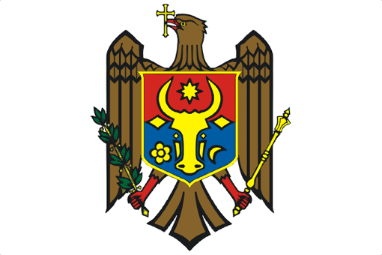

PERMANENT MISSION OF THE REPUBLIC OF MOLDOVA

UPR Working Group
25th Session
Universal Periodic Review of Hungary

Statement of the Delegation of the Republic of Moldova
Delivered by Ms. Olga Bogdan, Second Secretary
(Geneva, 4 May 2016)

Mr. President,

We welcome the distinguished Hungarian delegation to the UPR Working Group and thank the head of the delegation for the detailed national report and for today’s informative presentation.

The Republic of Moldova commends Hungary for the actions undertaken since the first UPR review to strengthen the legal framework and institutional capacities for the promotion and protection of human rights.

We welcome, in particular, the creation of the Ombudsman institution, in conformity with the Paris Principles, as well as the setting up of an inter-ministerial working group to monitor and promote human rights.

Following our recommendation to Hungary in the first UPR cycle, while positively noting the adopted legal measures to criminalize domestic violence, we would like to learn whether specific provisions related to other forms of violence, such as economic and psychological violence, were addressed in law.

Furthermore, we acknowledge the actions towards enhancing the child-friendly administration of justice, including by establishing hearing rooms for children in police units and enhancing the system of probation officers for child offenders. At the same time, we echo the concerns of international human rights mechanisms regarding lowering the age of criminal responsibility from 14 to 12 years for a number of offences.

From this perspective, we recommend Hungary to take necessary measures for strengthening its specialized juvenile justice system in compliance with the Convention on the Rights of the Child and to continue efforts for the reintegration of former child offenders in the society.

In conclusion, we wish Hungary success in the implementation of recommendations of the 2nd UPR cycle.

I thank you, Mr. President.

