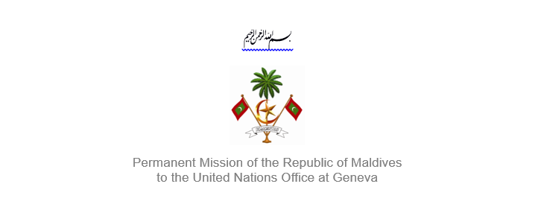25th Session of the Working Group of the Universal Periodic Review
2 – 13 May 2016, Geneva

Review of Hungary
4 May 2016

Statement by Ms. Rishfa Rasheed, Counsellor,
Permanent Mission of Maldives to the United Nations Office at Geneva

Check against delivery

Thank you, Mr. President,

The Maldives extends a warm welcome to the high-level delegation from Hungary to this review, led by His Excellency Mr. László Trócsányi, Minister of Justice of Hungary. We appreciate the voluntary mid-term report submitted by Hungary.

The Maldives welcome the adoption of the new Constitution, as well as legislations to strengthen human rights in the country. My delegation also welcomes the adoption of laws and policies on domestic violence, disabilities, and 2013-2016 National Strategy against Human Trafficking.

The Maldives welcomes Hungary’s establishment of the Subcommittee on Women’s Dignity as a part of the Parliament’s Committee on Culture, to focus on combatting domestic violence and the provision of security for women.

The Maldives would like to make the following recommendations:

- Take concrete measures to protect child victims of sexual exploitation and prostitution
- Raise the legal age of marriage for women and men to 18 years
- Review legislations to ensure that all persons with disabilities have a right to vote, and that they can participate in political and public life

Finally, we take a note of Hungary’s attempts to provide assistance to refugees and encourage Hungary to take a human rights based approach in dealing with the refugees and ensure all their rights are protected.

We wish the delegation of Hungary all the success during this review.

Thank you Mr. President.

