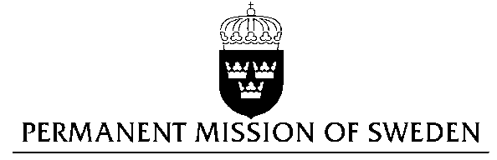
UN Human Rights Council

UPR 25th session

Statement by Sweden in the interactive dialogue on Greece

Delivered by H.E. Ambassador Veronika Bard
Geneva, May 3, 2016 (speaking time 1 min 20 sec)

Mr President,

Sweden wishes to welcome the delegation of Greece and express our thanks for the information provided in response to our advance questions.

We are aware that migration flows in 2015 resulted in an unprecedented increase in the numbers of asylum seekers, refugees, and migrants coming to Greece.

However, we note that problems related to access to- and quality of the asylum procedure, and conditions in detention centres, increased when people were denied the possibility to leave Greece.

Sweden recommends the Government of Greece:

- To work for the amelioration of the situation of migrants, particularly with regard to access to, and quality of, the asylum procedure, as well as the conditions in detention centres, and to ensure that full respect for human rights of all migrants and protection is granted to refugees in line with Greece’s international obligations.

- To continue its work to safeguard full respect of human rights for, and non-discrimination of, the Roma population in Greece, in line with Greece’s international obligations, and in doing so fully and effectively implement adopted strategies at all levels.

Thank you Mr. President

