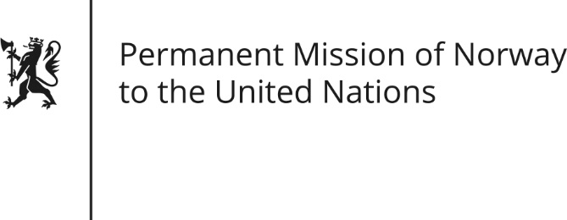

STATEMENT

Universal Periodic Review of Greece, 3 May 2016.

Norwegian statement by Andreas Gahr Brunsvig.
Thank you,

Norway welcomes the Greek delegation and commends the tangible progress Greece has done in many areas since the previous review.

Norway also commends the extraordinary efforts of Greece to handle the migration influx. While emphasizing the responsibility of all European countries for improving the situation for refugees and migrants in Europe, we recommend that Greece pays particular priority to improving reception conditions for refugees and migrants and continue its efforts for a more efficient asylum procedure.

The use of closed reception facilities and detention may be necessary in certain situations, for instance in order to secure proper registration of migrants and to enable lawful return of migrants. However, excessive use of detention of asylum-seekers is a cause for concern, in particular for minors. We recommend that Greece limit the use of detention of asylum seekers, refugees and stateless persons. We also recommend Greece to establish and adequately resource a well-functioning guardianship and care system for unaccompanied minor refugees or asylum seekers.

Norway has worked closely with Greece in promoting a more open and inclusive society, and note with appreciation efforts by Greek authorities and NGOs in combating hate speech and prejudice. We recommend undertaking further initiatives to address verbal abuse and hate speech directed against members of vulnerable groups, and to ensure sufficient focus on this topic in the education system.

Finally, Norway recommends Greece to implement measures to ensure more effective legal procedures and speedier resolution of legal cases; by creating mechanisms for out of courts settlements, adjudication of court cases by arbitration apparatuses and better use of information technology to enhance access to justice.

Thank you.

