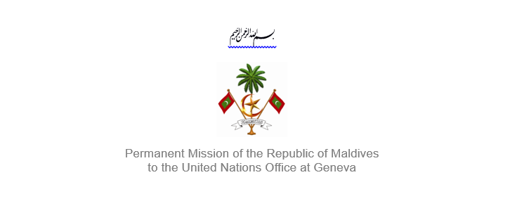25th Session of the Working Group of the Universal Periodic Review
2 – 13 May 2016, Geneva

Review of Greece
3 May 2016

Statement by Ms. Rishfa Rasheed, Counsellor,
Permanent Mission of Maldives to the United Nations Office at Geneva

Check against delivery

Thank you Mr. President,

The Maldives welcomes the delegation from the Greece to this review, led by His Excellency Mr. Kostis Papaioannou, Secretary-General for Transparency and Human Rights of Greece. We appreciate Greece’s submission of a voluntary mid-term report on implementation of recommendations.

The Maldives welcomes Greece’s ratification of the Convention of the Rights of Persons with Disabilities and its Optional Protocol, and the Optional Protocol to the Convention against Torture and Other Cruel, Inhuman or Degrading Treatment or Punishment. We further welcome the first National Action Plan on Human Rights.

The Maldives would like to make the following recommendations:

- Expedite the adoption of a National Action Plan to protect the rights of children
- Include human rights education in the curriculum of schools
- Take concrete steps to end discrimination against persons with disabilities

The Maldives appreciates the efforts of the Hellenic Coast Guard for rescuing refugees who have arrived on Greece’s shore by sea, and encourage the Government to continue and enhance the hospitality and assistance provided to them.

We wish the delegation of Greece all the success during this review.

Thank you Mr. President.

