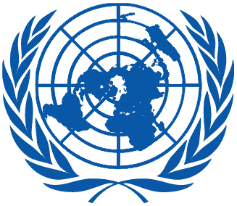 | Working Group on the Universal Periodic Review
Twenty-fifth session
Geneva, 2–13 May 2016

Order of the Day
Plenary Meetings – Room XX
Friday, 13 May 2016
AFTERNOON
16:00 – 18:00  20th meeting |  | Adoption of the recommendations section on:
Swaziland
– Draft report of the UPR Working Group: A/HRC/WG.6/25/L.11
 |  | Trinidad and Tobago
 |  | – Draft report of the UPR Working Group: A/HRC/WG.6/25/L.12
Thailand
– Draft report of the UPR Working Group: A/HRC/WG.6/25/L.13
Ireland
– Draft report of the UPR Working Group: A/HRC/WG.6/25/L.14
Notes:
All speakers scheduled to take the floor should provide the Secretariat beforehand with 25 copies of the statements. For general distribution, 250 copies are needed.
- The full text of statements are available: UPR extranet page
- Click on the following link to install the UNHRC iPad App:
https://build.phonegap.com/apps/529195/install
- Identity photo-badges valid for the session may be obtained by all delegations, if needed, from the UNOG Security and Safety Section at the “Pregny Gate” (Palais des Nations, 8-14 avenue de la Paix) from 8.00 a.m. to 5.00 p.m. upon presentation of a copy of their letter of accreditation and an identity document.
- PHOTOGRAPHS AND FILMING: Please note that only accredited media are permitted to film and take photographs in Room XX.

