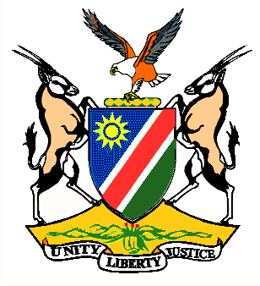

EMBASSY/PERMANENT MISSION OF THE REPUBLIC OF NAMIBIA

REPUBLIC OF NAMIBIA

Statement by H.E. Sabine Böhlke-Möller, Permanent Representative during the Interactive Dialogue on the Universal Periodic Review of Antigua and Barbuda, 09 May 2016, 14h30 – 18h00

Mr. President,
Namibia welcomes H.E. Ms. Maureen Payne, Senator and Parliament Secretary of Antigua and Barbuda to this Session of the UPR and commends them on the presentation of their national report.
We commend Antigua and Barbuda on the ratification of the International Convention on People with Disabilities and take note the adoption of the Children (Care and Adoption) Act and the Status of Children Act in 2015.
Namibia is pleased to take note of the various initiatives put in place to alleviate poverty, including the efforts taken to enhance the social protection schemes in Antigua and Barbuda. We wish the Government of Antigua and Barbuda success with this goal.
Whilst we are pleased to note the existence of a de facto moratorium on the death penalty for 24 years, we are concerned about the fact that the death penalty continued to enjoy popular support in Antigua and Barbuda and that there are frequent calls for its full reinstatement.
Namibia would like to recommend:
1. That the Government of Antigua and Barbuda considers ratification of the ICESCR and the ICCPR and its optional Protocols.
2. That the government of Antigua and Barbuda establishes a national human rights institution in accordance with the Paris Principles.
We wish Antigua and Barbuda all the best during their review.
I thank you Mr. President.

