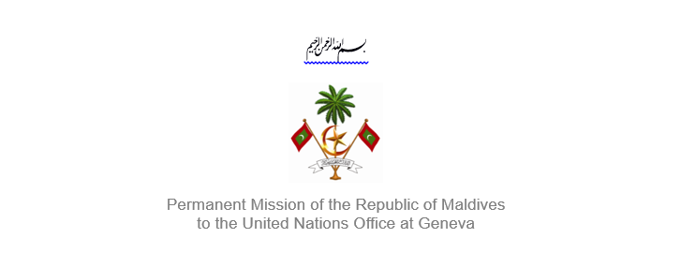
25th Session of the Working Group of the Universal Periodic Review
2 – 13 May 2016, Geneva

Review of Antigua and Barbuda
9 May 2016

Statement by Ms. Rishfa Rasheed, Counsellor,
Permanent Mission of Maldives to the United Nations Office at Geneva

Check against delivery

Thank you, Mr. President,

The Maldives extends a warm welcome to Her Excellency Ms. Maureen Payne, Senator and Parliament Secretary within the Ministry of Legal Affairs and Public Safety of Antigua and Barbuda to this review.

The Maldives expresses its appreciation for today’s presentation, and takes note of the national report, and implementation of the recommendations Antigua and Barbuda received during its first cycle.

We also welcome Antigua and Barbuda’s a Prevention Amendment Act 2015 that strengthens the Trafficking in Persons (Prevention) Act 2010.

The Maldives would like to make the following recommendations:

- Dedicate more resources to advance healthcare services
- Encourage to strengthen work regarding special education of persons with disabilities.
- Take steps to ensure implementation of Domestic Violence Act and Sexual Offences Act.

The Maldives appreciates the measures taken by Antigua and Barbuda’s laws relating to children and families passed in the Houses of Parliament in November 2015. The Maldives also strongly support Antigua and Barbuda’s Education Act (Cap 145) that provides that children are required to attend school from age 5 of 16.

The Maldives wishes Antigua and Barbuda all the success during this review.

Thank you Mr. President.

