check against delivery

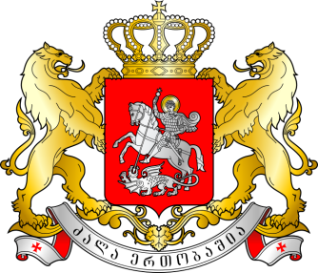
GEORGIA

Statement by Mr. Irakli Jgenti, Deputy Permanent Representative

The 24th Session of the UPR Working Group

UPR of Paraguay

Geneva, 20 January 2016

We warmly welcome the Delegation of Paraguay and thank the (Head of Delegation) for the presentation of the national report.

Georgia welcomes the ratification of the Convention on the Reduction of Statelessness and the Convention on the Status of Stateless Persons during the review period.

In respect to the Institutional and human rights infrastructure and policy measures, Georgia commends the Government of Paraguay for approval of the National Preventive Mechanism (NPM) and encourages timely allocation of resources enabling NPM to effectively fulfill its duties; welcomes the preparation of a National Action Plan on the rights of persons with disabilities.

Nevertheless, Georgia expresses concern related to the situation with the human rights defenders and judicial and administrative proceedings towards journalists. We urge the government to conduct relevant investigations.

Having said that, Georgia recommends:

1. To expedite a process related to the establishment of the national secretariat for indigenous peoples (SENAPI).
2. To continue efforts aimed at ensuring the availability and accessibility of the education system to all children and improvement of schools' infrastructure.

We wish the delegation of Paraguay a successful UPR.

Thank you Mr. President.

