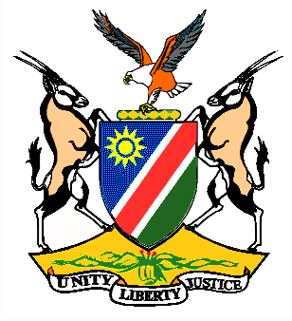

EMBASSY/PERMANENT MISSION OF THE REPUBLIC OF NAMIBIA

REPUBLIC OF NAMIBIA

Please Check Against Delivery

Statement by Ms. Gladice Pickering – Legal Attaché, during the Interactive Dialogue on the Universal Periodic Review of Palau, 21 January 2016, 14h30 – 18h00

Mr. President,
Namibia welcomes the delegation of Palau to the 24th Session of the UPR and commends them on the presentation of their national report for this review.
We take note of the signing of the core human rights instruments, like the ICCPR and ICESCR and would like to know from the delegation what efforts are underway for ratification of these instruments?
Namibia commends the Government of Palau on the enactment of the Family Protection Act and revision of the Penal Code to provide protective measures for children and deterrence of targeted crimes against children.
We encourage the Government of Palau to work on coordination with the international community to enforce international law on water protection and security, including the impacts of global sea level rising.
Namibia would like to recommend:
1. That Palau speed up efforts to ratify the ICCPR and the ICESCR.
2. That Palau takes active measures in order to ensure the protection of vulnerable groups in the society such as children, women and the elderly and to enact legislation on anti-discrimination.
We wish Palau all the best during their review.
I thank you Mr. President.

