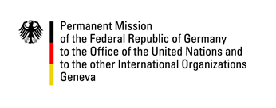

United Nations Human Rights Council
24th Session of the UPR Working Group

---
German questions and recommendations to
Niger
18 January 2016

German National Statement

Mr President,
Germany welcomes Niger to the UPR.

We recognize the efforts made in regard to cooperation with the United Nations human rights system, by for example issuing a standing invitation to all special procedure mandate holders to visit Niger.

Germany remains concerned, however, by some continuing issues relating to Niger’s international human rights obligations. We are in particular worried about the high rate of early, child and forced marriages and the protection of migrants and refugees from smugglers and human traffickers.

We therefore recommend the following:

- Protect human rights defenders and ensure that they are able to carry out their work free from harassment and intimidation.
- To prevent early, child and forced marriages by passing into law and effectively enforcing a minimum age of 18 for marriage.
- To enhance the protection of migrants and refugees by implementing the law on human trafficking and enhancing the operational capacities of the Commission Nationale d'Eligibilité au Statut de réfugié and the Agence Nationale de Lutte contre la Traite des Personnes.

Thank you.

Written questions submitted in advance
- When will Niger pass provisions into law that protect minors from early and forced marriage, including traditionally arranged marriages (“Code de la famille”)?
- How will Niger implement the law passed in May 2015 to combat human trafficking and smuggling, especially in the area of Agadez? In this regard, how will Niger improve the capacity of its security forces to protect migrants and refugees from smugglers?

