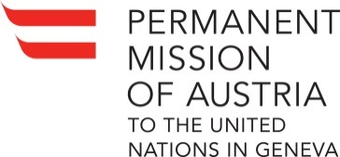 Check against delivery

UN Human Rights Council
24th Session of the UPR Working Group
2nd Cycle Review Review of Namibia, 18 January 2016

Statement by AUSTRIA

Austria welcomes H.E. Mr. Kawana and the delegation of Namibia and thanks them for their national report which reflects the serious and sustained engagement of Namibia in the UPR process.
Namibia deserves recognition as being among the top group of countries in its region regarding the overall level of protection of human rights of its citizens and we would like to encourage its government to continue on this path.

With a view to possibilities to further improve the Human Rights situation in the country, we offer the following recommendations:

- Regarding the Caprivi trial provide adequate compensation for the 35 persons acquitted who have spent long periods in remand detention.
- Continue efforts to improve the access to adequate land by ethnic minority groups which have been deprived of their original lands
- Facilitate the access of ethnic minority group children to education, for instance by allowing them to attend school in their traditional dress or by providing them with free school uniforms
- Reconsider the country’s position on a possible withdrawal as a state party to the ICC Rome Statute

Finally, we would like to ask which steps are envisaged, as announced in March 2015, to ensure that women in customary marriages enjoy rights equal to those in civil marriages.

Thank you.

