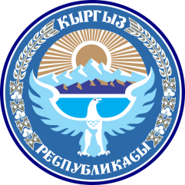 | Permanent Mission of the Kyrgyz Republic

Please, check against delivery

Statement of the Kyrgyz Republic
24th Session of the UPR Working Group Review on Latvia
26 January, 2016

Thank you Mr. President,
Kyrgyzstan welcomes the delegation of Latvia and is pleased to note that the authorities of Latvia are working consistently to improve and strengthen human rights institutions in constructive cooperation with treaty bodies and special procedures. Latvia has a standing open invitation to all United Nations Special Procedures mandate holders. We note the progress made in gender equality including women involvement in decision-making, especially in economy.
Mr. President,
We welcome the efforts of the Government of Latvia to promote and protect human rights, and would like to bring forward the following recommendations:

1) To ratify International Convention on the Protection of the Rights of All Migrant Workers and Members of their Families and the Optional Protocol of the Convention against Torture;

2) To support the teaching of minority languages and cultures in minority schools;

3) To continue efforts to reduce the number of non-citizens.
Mr. President,
My delegation strongly believes that Latvia will further strengthen institutions that promote human rights, democracy and the rule of law.

I thank you!

