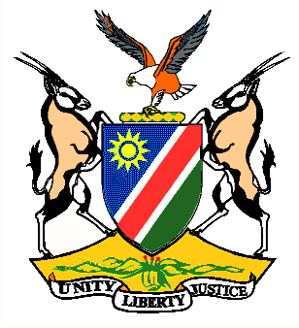

EMBASSY/PERMANENT MISSION OF THE REPUBLIC OF NAMIBIA

REPUBLIC OF NAMIBIA

Statement by Ms. Gladice Pickering – Legal Attaché, during the Interactive Dialogue on the Universal Periodic Review of Latvia, 26 January 2016, 09h00 – 12h30

Mr. President,
Namibia welcomes the delegation of Latvia to this session of the UPR Working Group and commends them on the presentation of their national report.
We are pleased to note the progress made with regards to gender equality in Latvia and the high number of women’s participation in the economy of the country. We take further note of the programmes and policies underway to enhance societal integration.
Namibia commends Latvia on the accession to the Second Optional Protocol to the International Covenant on Civil and Political Rights on the abolition of the death penalty.
Namibia would like to recommend:
1. That the Government of Latvia takes measures to strengthen the role and capacity of the Ombudsman to address issues such as non-discrimination.
2. That the Government of Latvia considers ratification of the Optional Protocol to the Convention on the Elimination of Discrimination against Women and to take measures in order to combat discrimination against women.
We wish Latvia all the best during their review.
I thank you Mr. President

