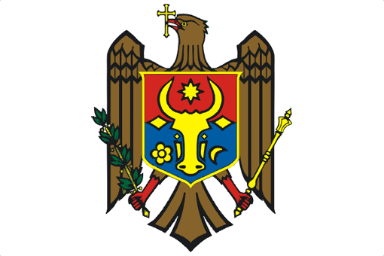

PERMANENT MISSION OF THE REPUBLIC OF MOLDOVA

UPR Working Group
24th Session
Universal Periodic Review of Denmark

Statement of the Delegation of the Republic of Moldova
Delivered by H.E. Victor Moraru, Ambassador, Permanent Representative

(Geneva, 21 January 2016)

Mr. President,

Let me welcome the distinguished delegation of Denmark to the UPR Working Group and thank the head of the delegation for the presentation of the National Report.

The Republic of Moldova commends Denmark for its solid human rights record and for its leadership in promoting human rights internationally.

We recognize the significant steps taken by the Danish authorities in order to implement recommendations from the first UPR cycle.

We welcome, in particular, the establishment of a Special Office for Children under the Parliamentary Ombudsman Institution and the initiatives undertaken to safeguard the rights of vulnerable children and children at risk.

We note, however, the concerns of Treaty Bodies regarding the large number of children placed in institutional care and would be interested to learn more about actions undertaken for the inclusion of children with special needs into elementary schools, as well as for ensuring that family-type rather than institutional care is the preferred form of care provided to children deprived of a family environment.

Furthermore, we appreciate the actions undertaken to prevent and combat domestic violence and, bearing in mind the calls for more focused attention to children living in domestic violence, we recommend Denmark to ensure that all cases where children have been a victim of domestic violence or witnessed such violence are properly documented and registered and that social recovery and reintegration services of child victims are reinforced.

I thank you, Mr. President.

