Check against delivery

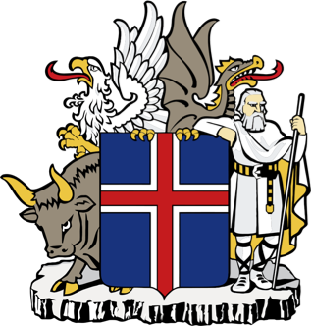

ICELAND
Statement by Mr. Thordur Sigtryggsson

UPR 24. Session – January 2016

www.iceland.is/iceland-abroad/efta

Iceland warmly welcomes the delegation of Denmark and thanks them for their comprehensive report. We applaud the Kingdom of Denmark’s efforts to place human rights at the forefront of its national agenda both home and abroad.

The refugee and migration crisis continues to pose difficult and complicated challenges for all states. We urge the Danish Government to live up to its own high human rights and humanitarian standards and refrain from taking any measures that would undermine its international obligations towards refugees.

Iceland makes the following recommendations to the Kingdom of Denmark:
- Ensure that the best interests of the child are fully considered when deciding on asylum cases and to uphold international obligations under the 1951 Refugee Convention.
- Amend the Marriage Law in the Faroe Islands to allow for same sex marriages and to ensure that the definition of rape in the Faroese legislation is brought into line with international standards so that rape is criminalized in all circumstances, including within marriage.

- Reform and upgrade municipal competences and accountability in Greenland in order to apply constructive measures and to promote protection of the child against violence, and to assist families in rehabilitation efforts on substance abuse and addiction.
Finally, Iceland wishes Denmark a successful review.

