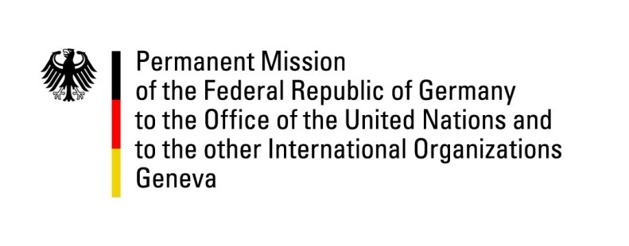

United Nations Human Rights Council
24th Session of the UPR Working Group

Geneva, 21 January 2016
---
German recommendations
to
Denmark

Mr. President,

Germany welcomes the delegation of Denmark to the UPR and commends the government for its commitment to upholding human rights and its increased efforts to place human rights at the forefront of its national agenda.
The government has however not yet ratified the International Convention for the Protection of All Persons from Enforced Disappearance, as agreed to during its first review.

Germany would like to submit the following recommendations:

- Ratify as soon as possible the International Convention for the Protection of All Persons from Enforced Disappearance and fully recognize the competence of the Committee on Enforced Disappearances, as provided for in articles 31 and 32 of the Convention
- Provide the Special Office for Children with a mandate and additional powers to enable it to provide advisory and legal assistance in a wider range of cases.

Thank you, Mr. President.

