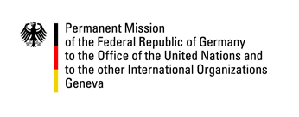

United Nations Human Rights Council
24th Session of the UPR Working Group

---
German questions and recommendations to
Belgium
20 January 2016

German National Statement

Mr. President,

Germany warmly welcomes the delegation of Belgium to the UPR and thanks for the report to the working group. We commend Belgium for the progress made since its last review in 2011 and for its continued engagement with human rights mechanisms. We also welcome Belgium as a new member of the Human Rights Council in 2016.

Germany wishes to offer the following recommendations:

- Continue to decrease prison over-crowding by providing new and adequate detention facilities.
- Provide specialized detention centres for mentally ill or addict detainees that respect their special needs and circumstances.
- Establish a National Human Rights Institution in full accordance with the Paris Principles.

Thank you, Mr. President.

Questions submitted in advance with regard to the UPR of Belgium – 20 January 2016 / UPR24

- How does Belgium plan to substantially reduce prison over-crowding and what measures are taken to decrease the number of detainees to significantly less than 10,000 nationwide?
- How does Belgium support victims of domestic and sexual violence, particularly with regard to encouraging them to report crimes to relevant authorities?

