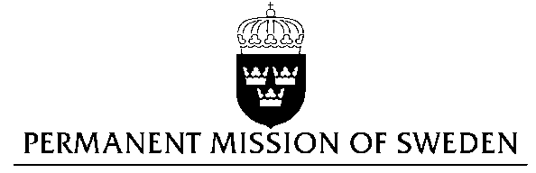
UN Human Rights Council

UPR 24th session

Statement by Sweden in the interactive dialogue on Belgium

Delivered by Minister Counsellor Josefin Simonsson Brodén
Geneva, January 20, 2016 (speaking time 1 min 10 sec)

Mr President,

Sweden wishes to welcome the delegation and express our thanks for the information related to our advance questions.

Sweden recommends to the Government of Belgium:

- to fully implement its national action plan to combat intimate partner violence and other forms of domestic violence.

- to make further efforts to enhance integration in general, through inter alia addressing unemployment among young and foreign-born citizens, and in particular to prevent radicalisation.
Sweden commends the Belgian initiative to reduce violence against women as defined in the “National action plan to combat intimate partner violence and other forms of domestic violence 2015-2019”. (A country-wide study commissioned by Amnesty International in 2014 found that a quarter of the women surveyed reported having suffered sexual violence from their partners.)

A large number of the Belgian population is born outside of Belgium and 10 percent of the population are foreign nationals. The unemployment rate is high among foreign-born citizens, especially for those born outside of the EU. (There are residential areas in Belgium where the unemployment rate for people aged 18-25 is close to 50 percent. The unemployment rate for the same age-group in the country is close to 20 percent (2012).)

Thank you, Mr. President

