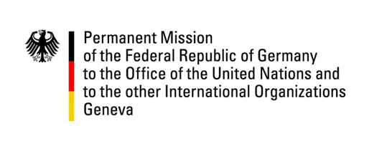

United Nations Human Rights Council
23rd Session of the UPR Working Group

Geneva, 04 November 2015
---
German questions and recommendations to
Rwanda

German National Statement

Mr President,

Germany commends the Government of Rwanda for its efforts to strengthen the protection of human rights in the country, including the fulfillment of nearly all of the MDGs and its willingness to implement a large majority of the recommendations from its last UPR.

We welcome positive developments regarding freedom of the press in Rwanda, in particular the establishment of the Rwanda Media Commission for self-regulation of the media. We are, however, worried that no final version of the Prime Minister’s Order on the competencies of the Rwanda Media Commission has been circulated.

In addition, we are concerned about ongoing reports alleging violations of due process rights, such as prolonged and incommunicado pretrial detention.

Germany would like to therefore make the following recommendations:

One: To ensure that international obligations concerning due process and fair trial rights are respected and fulfilled at all times.

Two: To protect freedom and self-regulation of the press by clarifying and strengthening the competencies of the Rwanda Media Commission.

Three: To intensify measures to reduce chronic malnutrition of children.

Thank you, Mr President.
Questions submitted in advance by Germany:

1 – The International Covenant on Economic, Social and Cultural Rights, to which Rwanda is a State Party, sets out the right of everyone to adequate food. Despite steady economic growth and foreign aid from donors, chronic malnutrition of children is reported to remain widespread. 38 % of children under the age of five are reported to be suffering from stunting. How does the Government of Rwanda plan to tackle this issue and fulfill a child’s right to adequate food?
2 – There have been allegations of arbitrary detention and ill-treatment of persons in the detention center known locally as the “Gikondo Transit Center” in Kigali. Many of the persons in detention there stem from the most marginalized groups of society. The ill-treatment that has reportedly taken place includes on one hand violence against persons in detention and living conditions that do not conform to Rwanda’s international legal obligations. Are there any plans to thoroughly investigate the allegations of arbitrary detention and to put in place measures to prevent such incidents in the future?

