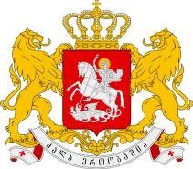

Statement of the Permanent Mission of Georgia to the UN Office
and other International Organizations in Geneva

23nd Session of the UPR Working Group
Universal Periodic Review of Rwanda
Geneva, 4 November 2015
Check against delivery

We warmly welcome the Delegation of Rwanda and thank the Head of Delegation for the presentation.

Georgia welcomes the decision of the Government of Rwanda to issue a standing invitation to all Special Rapporteurs.

Georgia also welcomes the reforms made in the national legislation in relation to the right to information and the freedoms of expression and association.

We commend the Government of Rwanda for building new prison facilities and for the efforts that had been taken to reduce overcrowding in prisons.

In the light of the aforesaid Georgia recommends:

- to implement the provisions of the OPCAT
- to accelerate the development of the National Human Rights Action Plan

With this in mind, my delegation wishes the delegation of Rwanda a successful UPR.

Thank You.

