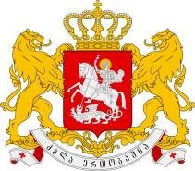

Statement of the Permanent Mission of Georgia to the UN Office
and other International Organizations in Geneva

23nd Session of the UPR Working Group
Universal Periodic Review of the Sultanate of Oman
Geneva, 5 November 2015
Check against delivery

We warmly welcome the Delegation of Sultanate of Oman and thank the Head of Delegation for the presentation.

Georgia acknowledges steps taken by the Government of the Sultanate of Oman in the field of the protection of the rights of the Child and promoting the role of women, although we encourage the Government to apply more efforts to reach the international standards.

In the light of the aforesaid Georgia recommends:

- to provide more opportunities to women to be represented in high-level government posts;
- to continue efforts to prohibit child labor.

