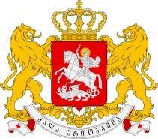

Statement of the Permanent Mission of Georgia to the UN Office
and other International Organizations in Geneva

23nd Session of the UPR Working Group
Universal Periodic Review of Myanmar
Geneva, 6 November 2015
Check against delivery

We warmly welcome the Delegation of Myanmar and thank the Head of Delegation for the presentation.

Georgia welcomes ongoing democratization process and encourages the Government of Myanmar to continue to do so.

Georgia welcomes the Presidential amnesties.

Georgia also welcomes Myanmar joining important international legal instruments, including CRPD and ICESCR.

In the light of the aforesaid Georgia recommends:

- to accelerate reforms with the aim to guarantee good governance and more vigorously address the issue of corruption;
- to ratify CAT and ICCPR

With this in mind, my delegation wishes the delegation of Myanmar a successful UPR.

Thank You.

