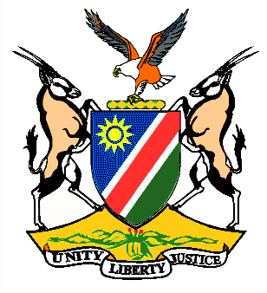

EMBASSY/PERMANENT MISSION OF THE REPUBLIC OF NAMIBIA

REPUBLIC OF NAMIBIA

Please Check Against SStatement Statement by Ms. Gladice Pickering – Legal Attaché, during the Interactive Debates on the Universal Periodic Review of Micronesia, 02 November 2015, 09h00 – 12h30

Mr. President,
Namibia welcomes the delegation of the Federal States of Micronesia to the 23rd Session of the UPR and commends them on the presentation of their national report for this review.
We are pleased to note the launch of the Child Protection Baseline Report (CPBR) in October of 2014, accompanied by the Atlas of the 2013 Child Equity Social Indicators.
We commend Micronesia on the completion of a Family Health and Safety Study in 2014, which is the first research effort to gather comprehensive information on violence against women in Micronesia.
Namibia makes the following recommendations:
1. That Micronesia considers ratification of the ICESCR and ICCPR as soon as possible.
1. That the Government of Micronesia takes legislative measures to prohibit all forms of corporal punishment of children in all settings.
4. That Micronesia considers removing all reservations under the CEDAW and takes all necessary measures to ensure full implementation of the provisions of the CEDAW.
We wish the Federal States of Micronesia all the best during their review.
I thank you Mr. President

