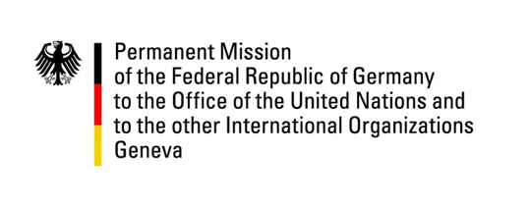

United Nations Human Rights Council
22nd Session of the UPR Working Group
Geneva, 05.05.2015

---
German recommendations to
Mongolia

German National Statement

Mr. President,

Germany welcomes the progress made by the Government of Mongolia since its last UPR. We particularly commend the draft new Criminal Code removing all provisions relating to the death penalty.

Despite this positive development, we are concerned about ongoing impunity in cases of torture and ill-treatment and the disestablishment of the Special Investigation Unit on acts of torture. Furthermore we are concerned about prevalent reports of child work in artisanal mines although it was listed as a dangerous and hazardous work prohibited for children under the age of 18 by the Government of Mongolia.

We also commend the unequivocal stance the government of Mongolia has taken in favour of the protection of human rights on the internet by acceding to the Freedom Online Coalition and hosting its fifth ministerial conference.

We therefore have three recommendations to Mongolia:

- To take steps to effectively prevent child labour and protect children from exploitation, especially from work in hazardous labour conditions including artisanal mines, including to hold employers using child labour accountable and to bring them to justice.

- To ensure independent and effective investigations in cases of torture and ill-treatment in order to combat impunity in such cases, and to ensure that victims of torture obtain adequate compensation and rehabilitation.

- To ensure full respect of human rights, including the right to privacy and the right to freedom of expression, in all aspects of internet regulation, and adherence of any restrictions of those rights to the principles of legality, necessity and proportionality.

