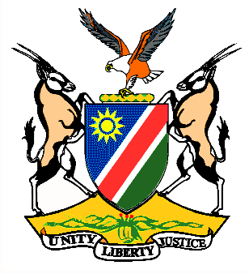

EMBASSY/PERMANENT MISSION OF THE REPUBLIC OF NAMIBIA

REPUBLIC OF NAMIBIA

Please Check Against SStatement Statement by Ms. Gladice Pickering, Legal Attaché during the Interactive Debates on the Universal Periodic Review of Andorra, 07 May 2015, 09h00 – 12h30

Thank you Mr. President,
Namibia welcomes the delegation of Andorra to the 22nd Session of the UPR and commends Andorra on the presentation of their national report for this review.
My delegation is mindful of the challenges facing Andorra as a result of the economic crisis that impacted heavily on its economy and population, since its last review. We applaud the efforts undertaken by the Government of Andorra to overcome these challenges, such as the protection for vulnerable groups and assistance for families.
Namibia commends Andorra for passing the Act on the Elimination of Gender-based and Domestic Violence, adopted in January 2015 that provides for the establishment of a National Commission for the Prevention of Gender-Based and Domestic Violence.
Namibia recommends the following:
1. That Andorra considers ratifying the ICESCR.
2. That Andorra establishes authoritative institutions at national level to combat racism, racial discrimination, xenophobia, anti- Semitism and intolerance and to raise awareness amongst the Andorran population on these manifestations.
We wish Andorra all the best during their review.
I thank you Mr. President

