c

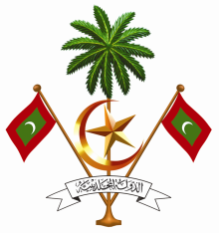

Permanent Mission of the Republic of Maldives
to the United Nations Office at Geneva

20th Session of Universal Periodic Review Working Group
Geneva, 27 October – 7 November 2014

Review of Angola, 30 October 2014

Statement by Ms. Rishfa Rasheed, Counsellor / Chargé d’ affaires, a.i.,
Permanent Mission of Maldives to the United Nations Offices in Geneva

Check Against Delivery

Thank you Mr. President
My delegation welcomes delegation of Angola to the UPR Working Group and the submission of the national report. We commend Angola’s efforts for the realization of human rights by signing international human rights instruments and urge the Government to expedite ratification of the pending instruments.
The Maldives would like to make the following recommendations:
- Enact legislation to guarantee the prohibition of torture and ill-treatment, as recognized in the constitution, and in line with the Convention Against Torture
- Intensify efforts to fully implement legislation to provide free education for all children, to ensure all children have equal access to education
The Maldives commends Angola for adopting the law against domestic violence in 2012, and the Presidential Decrees that followed to ensure its implementation. The Maldives also takes positive note of the national microcredit programme in 2013, which directly and indirectly benefited a large number of the population, 80 per cent of whom were women. The Maldives encourages the Government of Angola to strengthen the efforts to improving the economic situation in poor communities and rural areas, which will in turn lead to better health-care facilities and quality education and improve the well-being of its people.
My delegation fully understands the challenges faced by Angola in rebuilding the nation, and wishes it the best in the implementation of the 2013-2017 National Development Plan and more broadly the National Strategy for Long-Term Development "Angola 2025".
We wish Angola the best in this review.
Thank you Mr President

