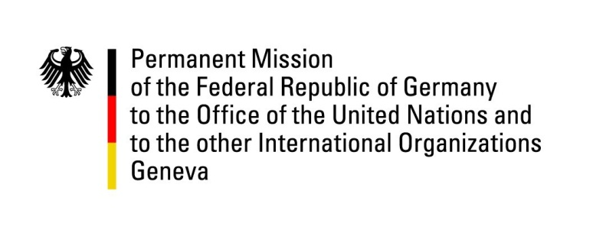

United Nations Human Rights Council
20th Session of the UPR Working Group

Geneva, 30.10.2014
---
German recommendations to
Angola

German National Statement

Thank you, Mr. President,
Germany welcomes the delegation and we would like to thank his Excellency, Minister…. for the presentation of the national report this morning. (Let me also thank your Excellency for responding to the advance questions posed by Germany).
We commend Angola for the efforts made since 2010. Regarding further steps, we urge the government to ratify and implement the signed human rights treaties, as well as to accelerate the implementation of outstanding recommendations.
Germany recommends Angola:
- To ensure the country-wide and effective implementation of the Law on Domestic Violence, and to ensure access of victims to medical (including psychological), legal and social support;
- To ensure that its housing policy is drafted and implemented in accordance with international human rights standards, including the access to an effective remedy and adequate compensation, and that the necessary assistance is provided to all evicted persons;
- To ensure that allegations of abuse by members of security forces are investigated in a prompt, thorough, credible and impartial manner; that those responsible, including officials with oversight responsibility are disciplined or prosecuted in accordance with international standards; and that victims of abuse receive adequate compensation by the State;
- To realize the right to education for all, including human rights education, by inter alia, ensuring the effective implementation of the law providing for free primary education for all children.

Thank you, Mr. President.

