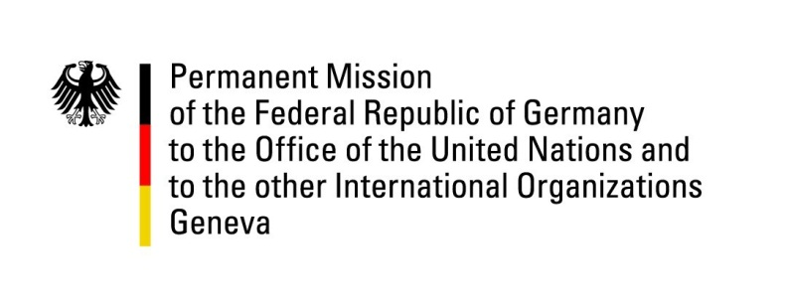

United Nations Human Rights Council
19th Session of the UPR Working Group

Geneva, 28.04.2014
---
German questions and recommendations to
Norway

German National Statement

Mister President,

Germany welcomes the delegation of Norway and appreciates the efforts Norway has undertaken in response to recommendations made during the previous UPR cycle. While recognizing Norway’s very good human rights record, we would like to put forward the following recommendations:

- To sustain its dialogue with indigenous groups affected by the intensified state’s mining activities in the North and to reach an agreement that is acceptable for both sides;

- To continue giving top priority to the issue of unaccompanied asylum-seeking minors placed in asylum centers and protecting them from disappearance, including providing the necessary resources, enhancing measures to quickly identify and bolstering previous efforts in this regard;

- To ratify the Optional Protocol to the Convention on the Rights of the Child on the sale of children, child prostitution and child pornography.

Thank you, Mister President.

Questions submitted in advance:

- In light of Norway’s plans to expand its mining activities and given the adoption of a new mineral policy in 2013, what measures is the state taking to protect the rights of indigenous people? How can traditional livelihoods, particularly grazing and fishing rights, be secured in a mining environment? Is Norway planning to continue the dialogue with affected population groups in order to find a mutually acceptable agreement?

- In 2009, Germany recommended to promote gender equality, particularly with regard to education and the position of women in the labor market. Is Norway still planning to fully implement the Gender Equality Action Plan 2014 launched by the former administration in 2011? Regarding the integration of female immigrants in the labor market, have there been notable improvements as a result of new policies and programs?

