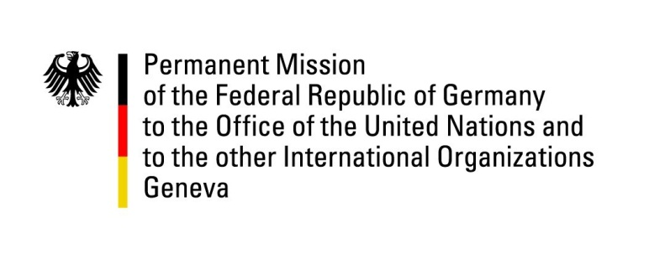

United Nations Human Rights Council
19th Session of the UPR Working Group

Geneva, 29.04.2014
---
German questions and recommendations to
Democratic Republic of Congo

German National Statement
By
H.E. Mr. Hanns H. Schumacher
Permanent Representative of the Federal Republic of Germany

Mr. President.
Germany warmly welcomes the delegation of the DRC to the 2nd cycle of the UPR and thanks Her Excellency, Madame Wivine Mumba, for her presentation. We particularly commend the authorities for the close cooperation with the international community during the preparation of the UPR report.
Despite progress achieved since 2009, the overall human rights situation remains worrisome. Germany calls upon the DRC to urgently address reports of serious human rights violations. In this context, accountability is not only of utmost importance for the victims but also for the stabilization of the entire country.
Germany would like to make the following recommendations:
1. To fully implement the plan of action to combat the recruitment and use of child soldiers and other grave violations of the rights of the child;
2. To ensure, respect and promote the democratic principle of the right to participate in public and political life without discrimination of any kind, so that everyone can pursue their activities freely and without fear of intimidation, threats, arbitrary arrests or other human rights violations.
3. To make economic, social and cultural rights a priority and to allocate sufficient resources.
4. To abolish the death penalty and to ratify the 2nd optional protocol of the ICCPR.
I thank you, Mr President.
Questions submitted in advance:
- The protection of civilians, in particular of women and children, remains of serious concern in the DRC. In this context, reports of crimes and sexual violence committed by members of State security forces and armed groups continue to surface. What concrete measures has the DRC adopted, for instance in the field of training and education, to further enhance awareness among all members of the police and army, regardless of rank, to protect civilians and their human rights? What steps has the government taken to strengthen the judicial system with a view to fight corruption, end impunity of those accountable and ensure international fair trial standards?

- In 2009, Germany recommended that the DRC strengthen its efforts to reform the FARDC and to improve military justice. So far, little progress has been made on a comprehensive reform of the military, although the Peace, Security and Cooperation Framework of 24 February 2013 commits the government of the DRC to continue, and deepen security sector reform, particularly with respect to the Army and Police. How and when the government of the DRC will implement the existing plans and enter into a substantial dialogue with MONUSCO and partners, acting under the mandate of SRSC Resolution 2147(2014)?

- In 2009, the DRC has adopted a national strategy to combat sexual and gender-based violence. Given the many worrisome trends in the region, what concrete measures and steps have been taken by the Congolese government to ensure the implementation of the national strategy and combat human rights violations committed on the basis of gender, gender identity, or sexual orientation?

- How did the DRC involve civil society in the preparation of its UPR process?

