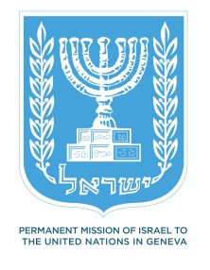
Statement on behalf of the State of Israel
UN Human Rights Council
UPR WORKING GROUP 19th SESSION
Democratic People’s Republic of Korea
Thank you, Mr. President.
Monopolization of the access to food leading to starvation, excessive control on freedom of movement, isolation from the rest of the world, discrimination on the basis of gender, suppression of all political and religious expressions, public executions, enforced disappearances, abductions and prison camps where people endure torture are only a fraction of the violations committed in the DPRK - contrary to all values of humanity, violating the very basic principles established by the United Nations Charter.
In line with the detailed findings of the report prepared by the COI on human rights in the DPRK, the State of Israel makes the following recommendations:
- Acknowledge the existence of human rights violations, including political prison camps, dismantle them and release all prisoners;
- Provide international humanitarian organizations and human rights monitors access to the camps and their surviving victims;
- Allow the establishment of independent newspapers and other social media, including free access to the internet;
- Allow all religious believers to exercise their religion independently;
- Take immediate measures to ensure gender equality; and
- Fully enshrine the right to fair trial and due process guarantees.
Thank you.

